GENERAL MANAGER

RECRUITMENT PACK

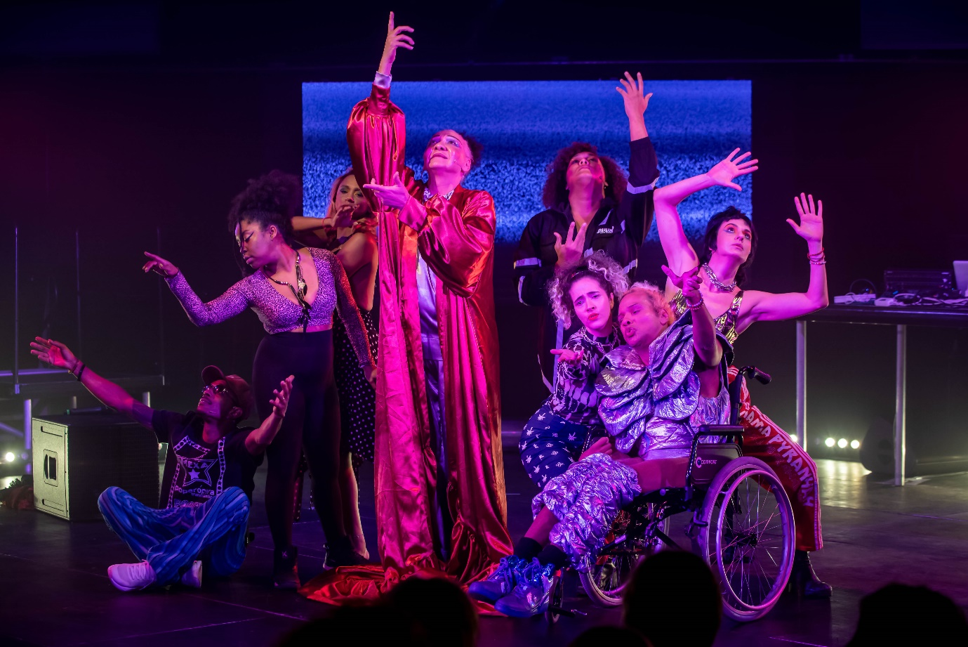

*PUMPITOPERA TRANSATLANTICA - MEXA. Image – JMA Photography*

Job Title**: General Manager**

Employer: **Transform**

We are seeking a highly organised and efficient **General Manager** to join our team in Leeds and play a key role in the smooth running of **Transform** as we plan and deliver biennial international festivals of adventurous performance and year-round support for trailblazing artists and creatives.

We are looking for someone who is excited about being part of a small but ambitious organisation and has a keen understanding of finance, reporting, HR and administration. You’ll be confident in being the go-to person in the team, maintaining a welcoming, productive and accessible physical and digital environment in which to work and setting up new processes to ensure **Transform** runs effectively and smoothly.

If you have an eye for detail, excellent administration skills, and want to ensure that effective systems can enable bold, powerful performance and festivals, then we’d love to hear from you.

**ABOUT TRANSFORM & THE JOURNEY SO FAR**

**Transform** is an engine-room for urgent, of-the-moment performance. Based in **Leeds**, our biennial **Transform festivals** takeover the city with powerful performance by local, national and international artists. We focus on reimagining what theatre can look like and do, celebrating the independent and adventurous spirit of our city, reflecting the socially conscious North, and connecting creatives and audiences to the world.

Year round we activate communities through co-creation and support the development of the next generation of artists and arts professionals. We support diverse, early career Northern creatives to make evolutionary steps in their careers.

*‘I often think about what our art sector would look like, if more artists received the support I have from Transform. They are willing to take risks, supporting artists that are often overlooked.’* – **Jamal Gerald.**

The biennial **Transform** festivals showcase our own creations and premieres, community co-creations concocted throughout the year, and an international performance programme of contemporary theatre, performance and dance. Whilst amplifying creative voices across **Leeds** and **the North,** the festival also brings extraordinary global voices to the city. The festival takes place in iconic arts venues (from **Leeds Playhouse** to **Yorkshire Dance** and **Opera North**) alongside car parks, community centres, clubs and school halls.

In the last 8 years we have achieved what many said was impossible – building an ambitious, inclusive and international festival during times of adversity. We have delivered 6 trailblazing international festivals bringing extraordinary, socially conscious performance to **Leeds**, fuelling a new generation of artists and audiences. These festivals have received substantial critical acclaim, attracted large and diverse audiences and established a powerful reputation nationally and internationally.

In 2023, **Transform**’s quality, ambition, social relevance and importance to the cultural landscape of Leeds, the North and England was recognised as the organisation joined **Arts Council England’s National Portfolio**. This marked a significant step-change in the development of the organisation, enabling us to think and plan strategically, to extend our reach, deepen our connections with our local communities and to develop even more ambitious projects. With increased resources, our 2023 edition was our most successful yet, nearly doubling audiences and more than doubling box office income versus 2021-22.

In December 2023, **Transform** was shortlisted for **The Stage’s 2024 International Award**. **The Stage Awards** recognise excellence in the theatre industry and this acknowledgement is a powerful testament to the success of **Transform 23**. **The Stage** described the 2023 edition as **‘Transform’s most ambitious yet’**, highlighting our position as ‘one of the most important international festivals in the UK’.

**THE FUTURE & TRANSFORM 25**

**Transform 25** (October 2025) will be our boldest, bravest and most inclusive festival yet: a celebratory culmination of our work over the first three years as an NPO. It will build on the huge success of previous festivals, bringing world-class culture to Leeds, deepening our connections in the Leeds City Region, supporting new creative practices and helping young people build careers in the arts.

With care, inclusivity and access at its core, **Transform 25** will place young people, local communities and artists from the city at the heart of the festival’s development and curation, acting as a catalyst for a new generation of artists, cultural leaders and change-makers.

The programme will be presented in partnership with major flagship arts institutions in the city including **Leeds Playhouse, Northern Ballet, Howard Assembly Rooms** and **Yorkshire Dance.**

You can read more about our vision and values [here.](https://transformfestival.org/about/)

You can read our 23-24 Annual & Festival Report [here](https://transformfestival.org/read-our-annual-report/).

You can find out more about our past work [here.](https://transformfestival.org/archive/)

**THE COMPANY**

**Transform** is a registered charity and a company limited by guarantee, established in 2015. A diverse-led, female-led company, **Transform** was founded by Creative Director **Amy Letman,** recently named by **The Stage** as one of 25 people expected to change the future of theatre. The organisation employs a core team of four, others including Founder and Creative Director **Amy Letman**, Executive Director **Ali Ford** and Producer **Ema Boswood**; complemented by a robust team of experienced freelancers with specialisms in technical, producing, marketing and engagement, that expands and contracts around delivery activity.

ABOUT THE ROLE

The **General Manager** will lead on ensuring the smooth and effective running of Transform’s financial, administrative and HR functions, creating or refining systems and processes where needed. The role will underpin the work of the Creative Director, Executive Director and Producer with effective administrative, operational and more strategic support.

This will include the administration and oversight of Transform’s financial processes, financial and funder reporting, data collation and monitoring, HR systems and processes. It will also involve providing a robust level of administrative support for the organisation, a general responsibility for its physical and digital office space, and an eagerness to uphold its values around access and environmental responsibility. Supported by the core and freelance team, the **General Manager** will play a role in the preparation and delivery of our biennial international festival, with a particular focus on operational aspects. This role is perfectly designed for someone who understands the importance of a thriving and ambitious organisation being underpinned by effective and fine-tuned systems and processes, with the expertise and know-how to deliver.

Job Description:

Finance & Funding

* + As a bank account signatory, have bookkeeping responsibility
  + Make bank payments to suppliers and staff and issue and monitor sales invoices
  + Posting of all sales receipts, grant income, purchase invoices, and other bank spend
  + Regular bank reconciliations and monitoring of earned income
  + With the Executive Director, maintain and monitor the organisation cashflow
  + Oversee credit card statements, receipts and reconciliation
  + Running and monitoring of petty cash
  + Manage the company overheads budget, seeking best value wherever possible
  + Liaise with accountant regarding Theatre Tax Relief Claims and other relevant matters
  + Complete the organisation’s Gift Aid claim annually
  + Support the Executive Director with the preparation of management accounts
  + Support the Executive Director and Accountant to develop annual accounts and trustees report
  + Be responsible for monitoring and administrating funding reporting (to funders including Arts Council England, Leeds City Council and trusts and foundations)
  + Support the Executive Director in developing funding reports

Operations & Administration

* + Maintain Transform’s company policies, ensuring policies are regularly reviewed and updated
  + Ensure data protection, first aid and safeguarding records are up to date and arrange training and briefing sessions
  + Lead on monitoring and data collection
  + Administrate the Transform board, organising all meetings, pulling together and distributing papers, minute-taking
  + Report to and update information for Companies House and Charities Commission
  + Ensure that appropriate insurance cover is maintained
  + Oversee IT equipment and provide support to the team on software and other IT issues
  + Office management, including being the point of contact for Hope Foundry (our landlord)
  + Manage Transform’s status as a registered Sponsor for Foreign Entertainers and administer VISA applications
  + Complete Foreign Entertainers return forms and submissions
  + Have oversight of festival travel, accommodation and per diem allocation, with the support of the Producer
  + Supported by the Executive Director and Producer, have an oversight of festival contracts
  + Oversee and administrate contact databases
  + Supported by an Operations Manager, have oversight of festival ticketing, front of house and volunteers
  + General office and festival administration

HR

* + Ensure that HR records, including annual leave allocations, are up to date and recorded
  + Liaise with our payroll provider to distribute payslips and arrange timely payment of wages, keeping them up to date with any changes to contracts
  + Issue and update staff and freelance contracts ensuring they are in line with current employment legislation
  + Carry out staff and freelancer induction and any related paperwork e.g. references, DBS checks and support with end of contract tasks e.g. arrange exit interviews
  + Coordinate recruitment processes
  + Update organisational HR policies and develop a staff handbook

Other

* + Work within Transform’s policies, including Health & Safety, Safeguarding and Equity & Inclusion
  + Participate in organisation meetings and events as required
  + Attend relevant training as and when required
  + Positively represent Transform at events
  + Advocate for the organisation's work within the sector and beyond
  + Any other duties appropriate to the post and organisation

Person Specification:

You will be a capable, personable and experienced **General Manager** who thrives on supporting organisations to run effectively and efficiently. You will enjoy developing and leading effective administrative, financial and operational systems and will be organised and diligent whilst enjoying the fast-paced nature of a small and ambitious arts organisation. You will have an interest in contemporary arts and understand the value of Transform’s work.

Essential skills and experience

* + Track record in organisation administration, office management or company management
  + Financial administration experience and knowledge of working with budgets and cashflow
  + Experience of reporting and monitoring
  + Experience of creating and maintaining systems and processes
  + Experience working in a strongly digital environment and ability to work with computer systems, software and spreadsheets
  + Highly organised and efficient with a strong eye for detail
  + Strong communication skills, written and verbal
  + Able to manage a broad range of tasks both time limited and ongoing and to be self-sufficient with time and task management
  + A passion for Transform’s work and a desire to work with the team to ensure the organisation delivers

Desirable

* + Knowledge and experience of delivering HR policies and procedures
  + Line management experience
  + Experience of using Xero or similar accounting software
  + Experience in a similar role for an arts organisation or charity
  + An understanding of the needs and demands of working in a small team

HOW WE WORK

We are building a festival that centres inclusivity and care, is co-created with communities and reflects the ideas and energies of those across the city and globe. We are working to ensure our organisation culture reflects this and the team contribute their own ideas and energies to Transform over the coming years.

The team

The **General Manager** will join a core team that consists of Creative Director Amy Letman, Executive Director Ali Ford and Producer Ema Boswood. In the months prior to the festival, our staffing expands as experienced freelancers and short-term staff support us to deliver the festival.

The perks

We have an accessible working space within a reclaimed building on Mabgate called Hope Foundry, home to several other creative organisations, with a rich heritage dating back to 1812 and now managed by MAP Charity. Mabgate is the alternative cultural heart of Leeds and a short walk to the city centre and some of the city’s major cultural venues on Quarry Hill. Hope Foundry is accessible by public transport, there is also a bike store on site, and we offer a Bike to Work scheme. There is a café due to open on site and we have access to a shared kitchen set-up including a kettle, microwave and fridge. As Transform staff you’ll get tickets to exceptional performances and festival events and we organise social gatherings with the team and board too. As well as becoming part of Leeds’ thriving creative community, you’ll have access to our national and international networks. Being part of a small team in a dynamic organisation means you will be able to put your stamp on the role, and meaningfully contribute to how the organisation grows and evolves over the coming years.

Working patterns

Transform is a creative organisation with a varied workflow, with activities increasing in the lead up to our festival. For this reason, it is important that our employees are able to work with us flexibly. We are seeking someone who can be based in or nearby to Leeds.

For most of the year we operate a hybrid model, combining the benefits of home working with in-person communication and collaboration. Generally, full-time staff are expected to be in the office three days a week (Monday to Wednesday) and part-time staff two days a week (Monday and Tuesday), with the option to work from home or in the office for the remaining contracted hours, subject to preference.

In the months leading to the festival, or for one-off events, increased in-person availability will be required and particularly during the festival itself all roles include some evening and weekend work. We have a TOIL and flexible working policy which is regularly reviewed to ensure we can meet the needs of the organisation and its workflow, whilst valuing staff wellbeing. Our usual office hours are generally 9.30am-5.30pm, however there is a level of flexibility here for those that require slightly different working patterns, to be agreed on an individual basis.

Equality, Diversity and Inclusion  
The representation across our current core team and board is 80% female, 30% LGBTQI+, 30% people who are ethnically and culturally diverse and experience racism in our society, 20% who identify as neuro-divergent and 10% who identify as disabled. We particularly welcome candidates for this role from people who are currently underrepresented within the UK arts sector including those from lower socio-economic backgrounds, people from the Global Majority, people who are disabled and neurodiverse.

CONTRACT DETAILS

Line manager:

Executive Director.

Responsible for:

Operations Manager (short term, freelance during festival).  
Payroll provider/Bookkeeper/Accountant (rolling freelance contracts).

Contract:

Part-time 4 days a week (0.8), 12-month contract (with potential of extension, subject to funding).

There is an expectation that the role will increase to full time over the month of the festival, with TOIL earned to be taken in the weeks following the festival delivery period.

Salary:

Salary: £32,000 pro-rata (£25,600 0.8).  
  
Pension:

Employer contribution 3%.  
  
Annual leave:

20 days per year* plus bank holidays (16 days pro-rata 0.8).

*Increasing to 25 days per year following the first year in the role).

Location:

Hope Foundry, Leeds. Minimum 3 days office-based Mon-Weds.  
  
Hours:

32 hours per week (including 30 minutes paid lunch break). Our usual office hours are 9.30am-5.30pm. This role will occasionally require some weekend and evening work.

References:

Any offer is subject to receipt of satisfactory references.

TO APPLY

Access & Inclusion  
We are committed to inclusion and to supporting creative people and staff needs. If you require this call out in a different format, would like any support completing the application, or would require support to undertake the role - don’t hesitate to let us know by contacting [info@transformfestival.org](mailto:info@transformfestival.org).

Pre-Conversation

If you have particular questions or would like to discuss the role or your circumstances further before applying – please email [siana-mae@transformfestival.org](mailto:info@transformfestival.org) subject line ‘General Manager query’ to arrange a conversation with the Executive Director.

Making an application

Please send a cover letter of no more than 2 sides of A4, along with your CV, outlining why you are suitable for the role with the job spec in mind, to [siana-mae@transformfestival.org](mailto:info@transformfestival.org) marking the subject line ‘General Manager Application’. We are also happy to accept applications via video or a different format for accessibility purposes.

Please submit an [Equal Opportunities monitoring form](https://www.surveymonkey.com/r/2425EqualOps) online, together with your emailed application.  
  
Closing date:

9am, Monday 6 January 2025

If your application is shortlisted for an interview, you will be contacted by 5pm on Tuesday 7 January 2025.

Interviews:

Tuesday 14 January 2025

Interview Process  
Following shortlisting you may be invited to interview - these will be in person at our office base in Hope Foundry. We will consider online interviews for any candidates who may require this due to access or geographical reasons. The interview panel will be communicated in advance. The start date for this role will be agreed with the successful candidate.

We look forward to hearing from you.